VIETNAM NATIONAL UNIVERSITY - HO CHI MINH CITY
INTERNATIONAL UNIVERSITY
SCHOOL OF COMPUTER SCIENCE AND ENGINEERING · DEPARTMENT OF DATA SCIENCE
LAB 1 REPORT
STATISTICAL LEARNING & INTRODUCTION TO PYTHON
(ISLR / ISLP CHAPTER 2)
Full Name: | Mai Dong Huy
Student ID: | ITDSIU24019
Course / Group: | IT171IU – Statistical Learning (Lab Group 1)
Instructor / Semester: | Semester 1, Academic Year 2026
―――――――――――――――――――――――――――――――――――――――――――――――――――――――
Task 0 – Environment Setup and Verification
The statistical learning Python environment was successfully set up and verified across both desktop IDE (Windows 11, Python 3.13) and Google Colab cloud environment.
Python version : 3.13.14
Executable : C:\Users\HUY\AppData\Local\Microsoft\WindowsApps\PythonSoftwareFoundation.Python.3.13_qbz5n2kfra8p0\python.exe
Operating sys. : Windows 11
numpy 2.3.0
pandas 2.3.0
matplotlib 3.10.6
sklearn 1.8.0
statsmodels 0.15.0
ISLP 0.4.1
Check Message : Hello, Mai Dong Huy! My statistical-learning environment works.
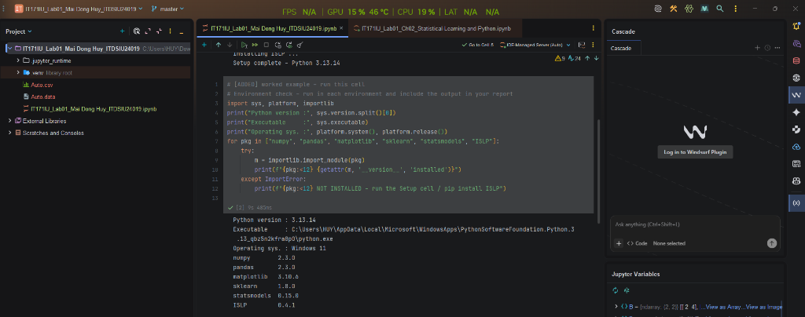
Exercise 1 – NumPy Warm-up
Vector v = (2, 4, ..., 40) reshaped to 4x5 matrix M:
M.shape: (4, 5) | M.ndim: 2 | M.dtype: int64
Row means: [ 6. 16. 26. 36.]
Column std: [11.18, 11.18, 11.18, 11.18, 11.18]
View mutation test: B = M[:2, :2]; B[0, 0] = -1 -> M[0, 0] changed to -1 (True)
Copy mutation test: B_copy = M[:2, :2].copy(); B_copy[0, 0] = -1 -> M[0, 0] remained 2 (False)
Interpretation: Slicing a NumPy array produces a view sharing memory with the parent array, causing modifications to B to alter M directly. In contrast, .copy() allocates distinct memory so mutations stay isolated.
Exercise 2 – Random Numbers, Correlation & Saved Figure
Simulated n = 100 observations: x ~ N(0, 1), eps ~ N(0, 0.5^2), y = 2 + 3x + eps.
Empirical correlation between x and y: 0.9820
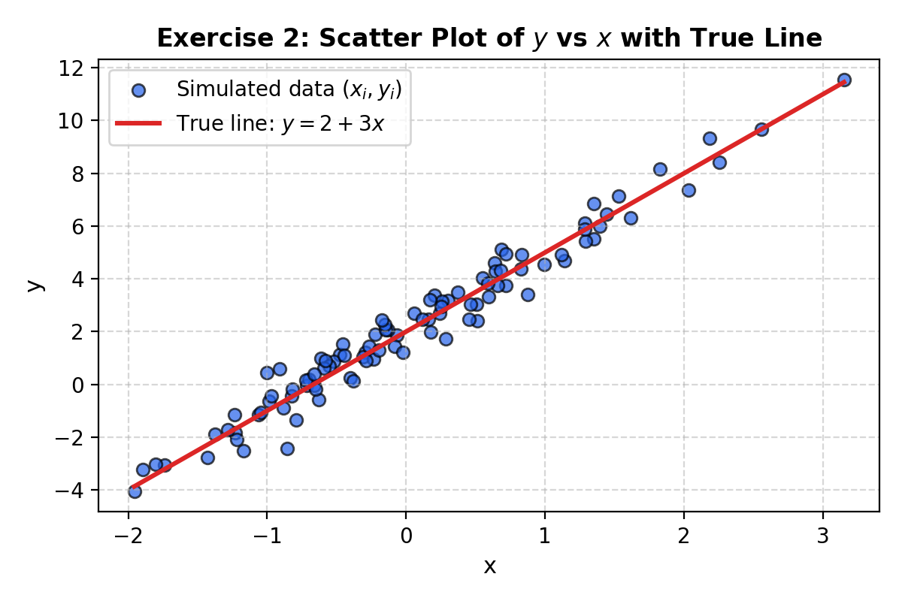
Interpretation: The sample correlation (~0.9820) confirms an exceptionally strong linear relationship with minimal residual noise. The fixed random seed (2026) ensures strict reproducibility; removing the seed produces fresh pseudo-random numbers upon each execution.
Exercise 3 – Cleaning the Auto Data
Loaded Auto.data with whitespace delimiter and '?' recognized as NaN.
Original shape: (397, 9) | Missing value rows: 5 | Cleaned shape: (392, 9)
Qualitative variables: origin (mapped to America, Europe, Japan), name
Quantitative variables: mpg, cylinders, displacement, horsepower, weight, acceleration, year
Quantitative Summary Table:
range mean std
mpg 37.6 23.445918 7.805007
cylinders 5.0 5.471939 1.705783
displacement 387.0 194.411990 104.644004
horsepower 184.0 104.469388 38.491160
weight 3527.0 2977.584184 849.402560
acceleration 16.8 15.541327 2.758864
year 12.0 75.979592 3.683737
Interpretation: Exactly 5 observations contained missing horsepower records and were eliminated via dropna(). The remaining 392 observations show large differences in dispersion: weight and displacement have standard deviations of 849.4 and 104.6, whereas acceleration is much more tightly clustered.
Exercise 4 – Subsetting Rows with iloc[]
Removed observations 10 through 85 (1-based indices 9 to 84), retaining 316 rows:
Subset statistics comparison:
Full Mean Sub Mean Delta Mean Full SD Sub SD Delta SD
mpg 23.4459 24.4044 +0.9585 7.8050 7.8673 +0.0623
cylinders 5.4719 5.3734 -0.0985 1.7058 1.6542 -0.0516
displacement 194.4120 187.2405 -7.1715 104.6440 99.6784 -4.9656
horsepower 104.4694 100.7215 -3.7479 38.4912 35.7089 -2.7823
weight 2977.5842 2935.9715 -41.6127 849.4026 811.3002 -38.1024
acceleration 15.5413 15.7269 +0.1856 2.7589 2.6937 -0.0651
year 75.9796 77.1456 +1.1660 3.6837 3.1062 -0.5775
Interpretation: Weight and displacement experienced the largest drops (-41.61 lbs and -7.17 cu.in. in mean), while average MPG increased by +0.96. The removed rows were clustered in early-1970s heavy American automobiles; their removal systematically shifts the sample towards lighter, more fuel-efficient cars.
Exercise 5 – Graphical Exploration
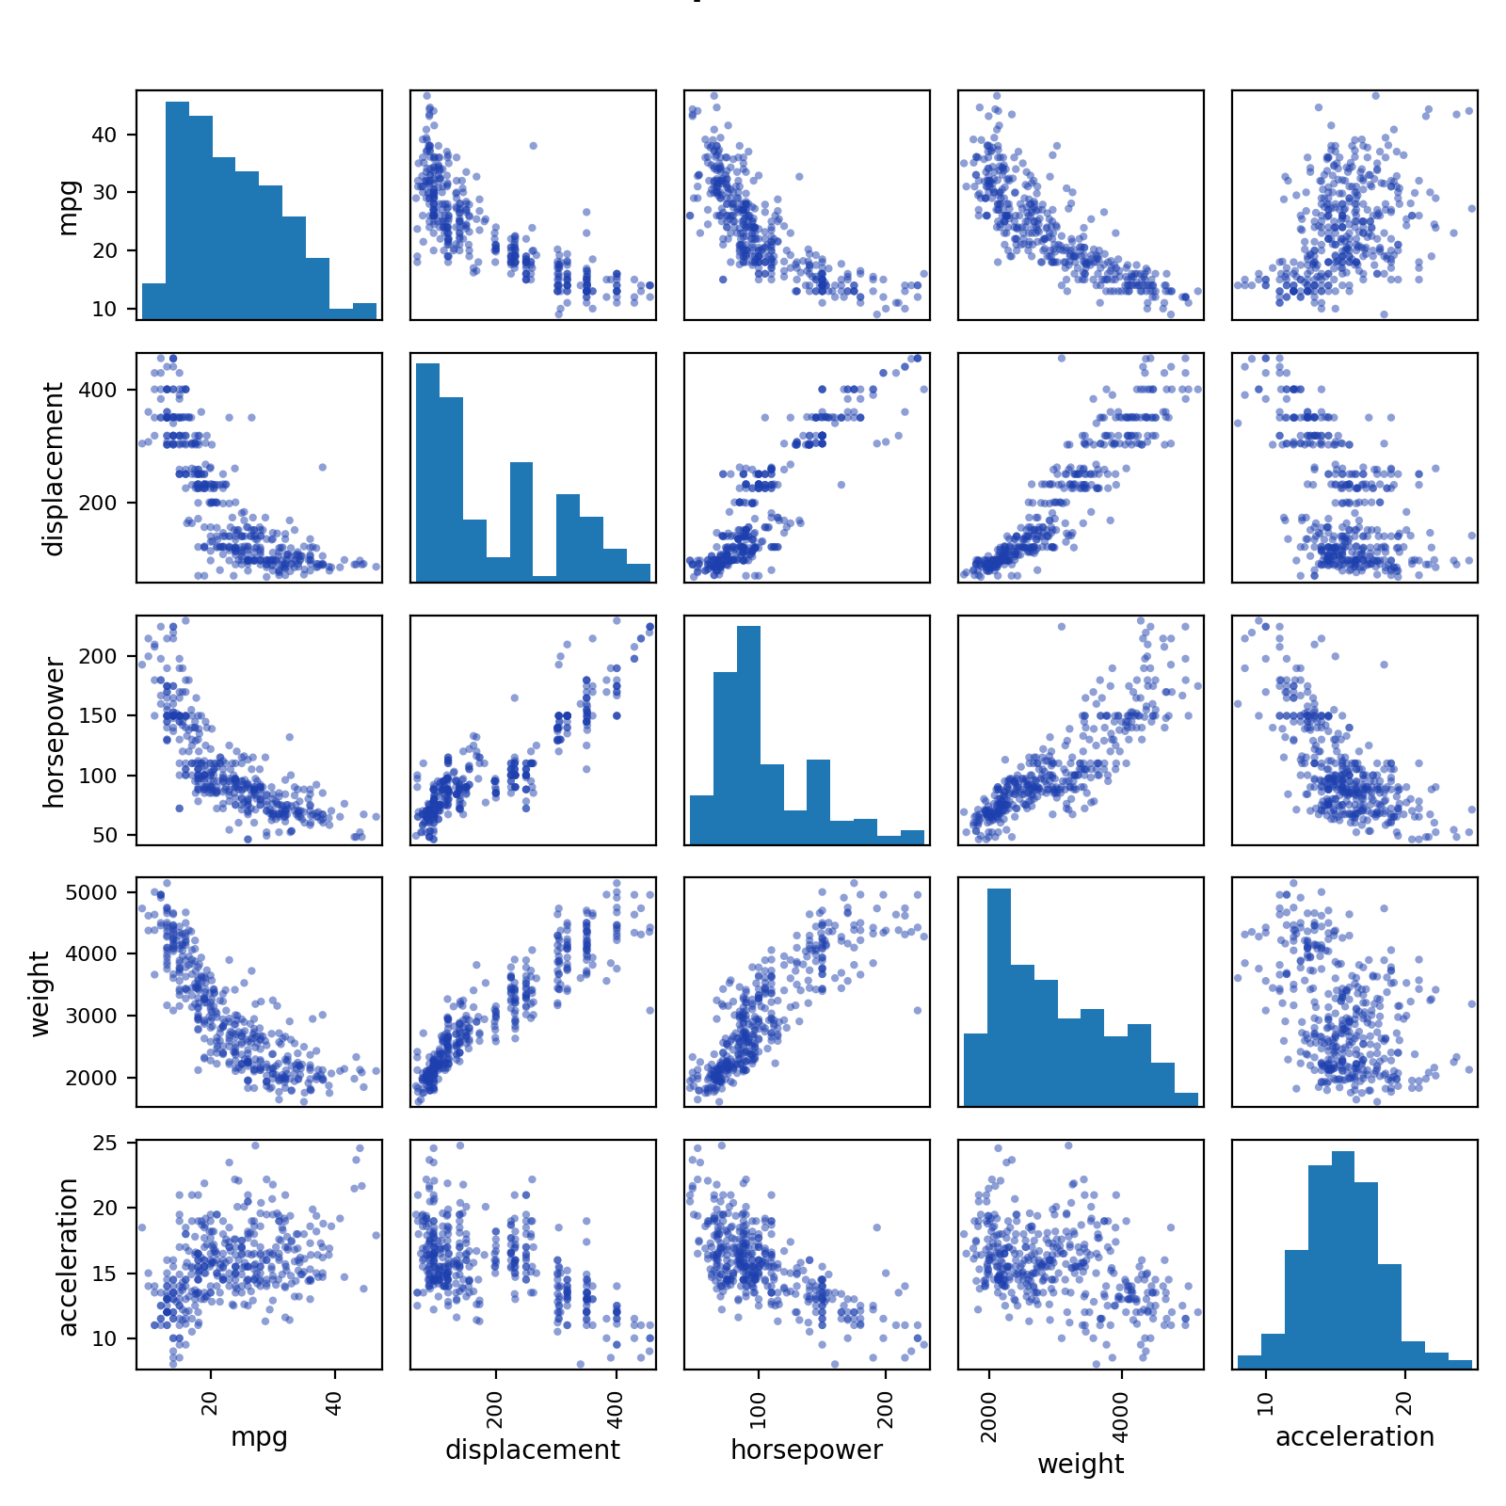
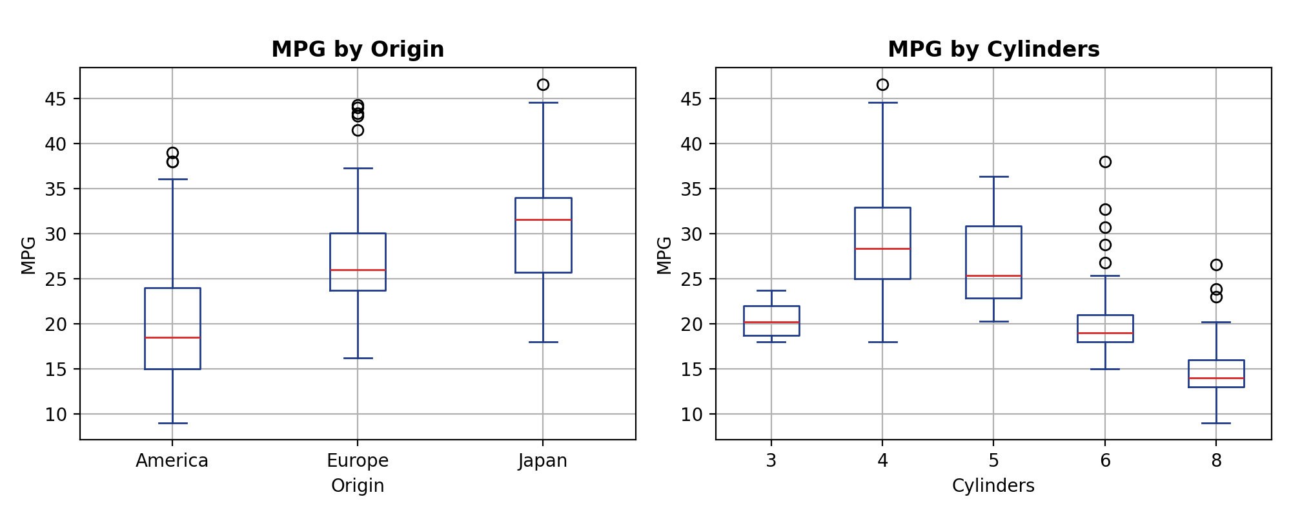
Key Findings: 1. Non-linear relationship: Weight, displacement, and horsepower exhibit distinct convex non-linear negative relationships with mpg (diminishing fuel economy degradation for very heavy vehicles).
2. Cylinders effect: 4-cylinder vehicles achieve significantly higher median MPG than 6- and 8-cylinder vehicles.
3. Origin disparity: European and Japanese vehicles deliver noticeably higher fuel economy than American vehicles.
Exercise 6 – The College Dataset
Exploration of 777 US Colleges from ISLP:
Total colleges: 777
Private colleges: 565 (Yes) vs 212 (No)
Elite colleges (Top10perc > 50): 78 (Yes) vs 699 (No)
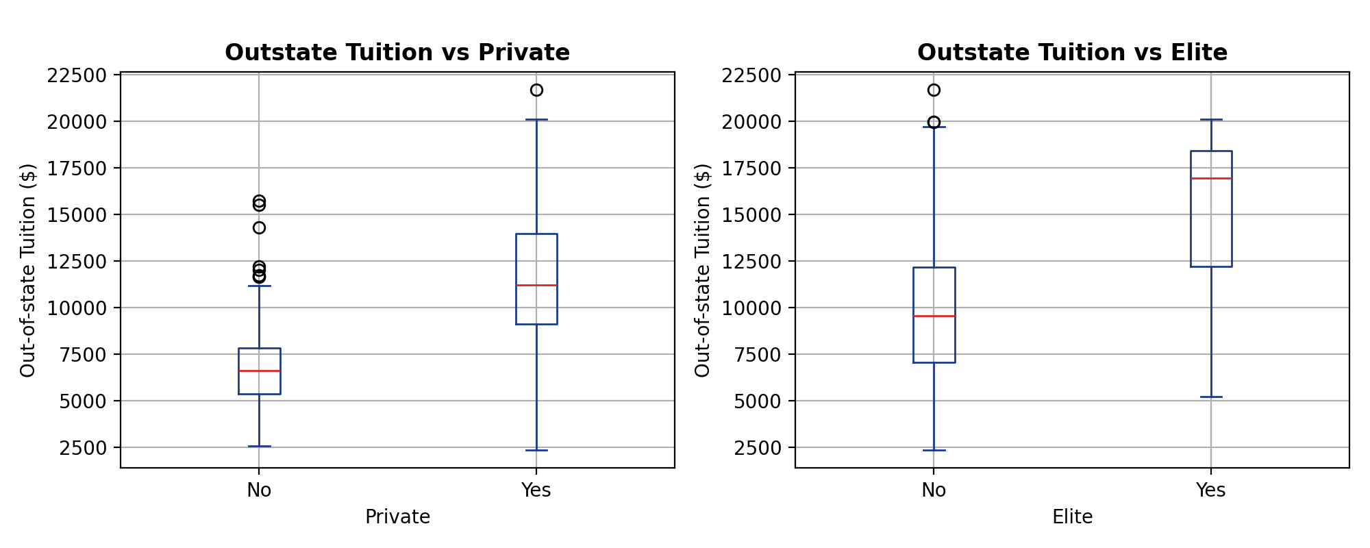
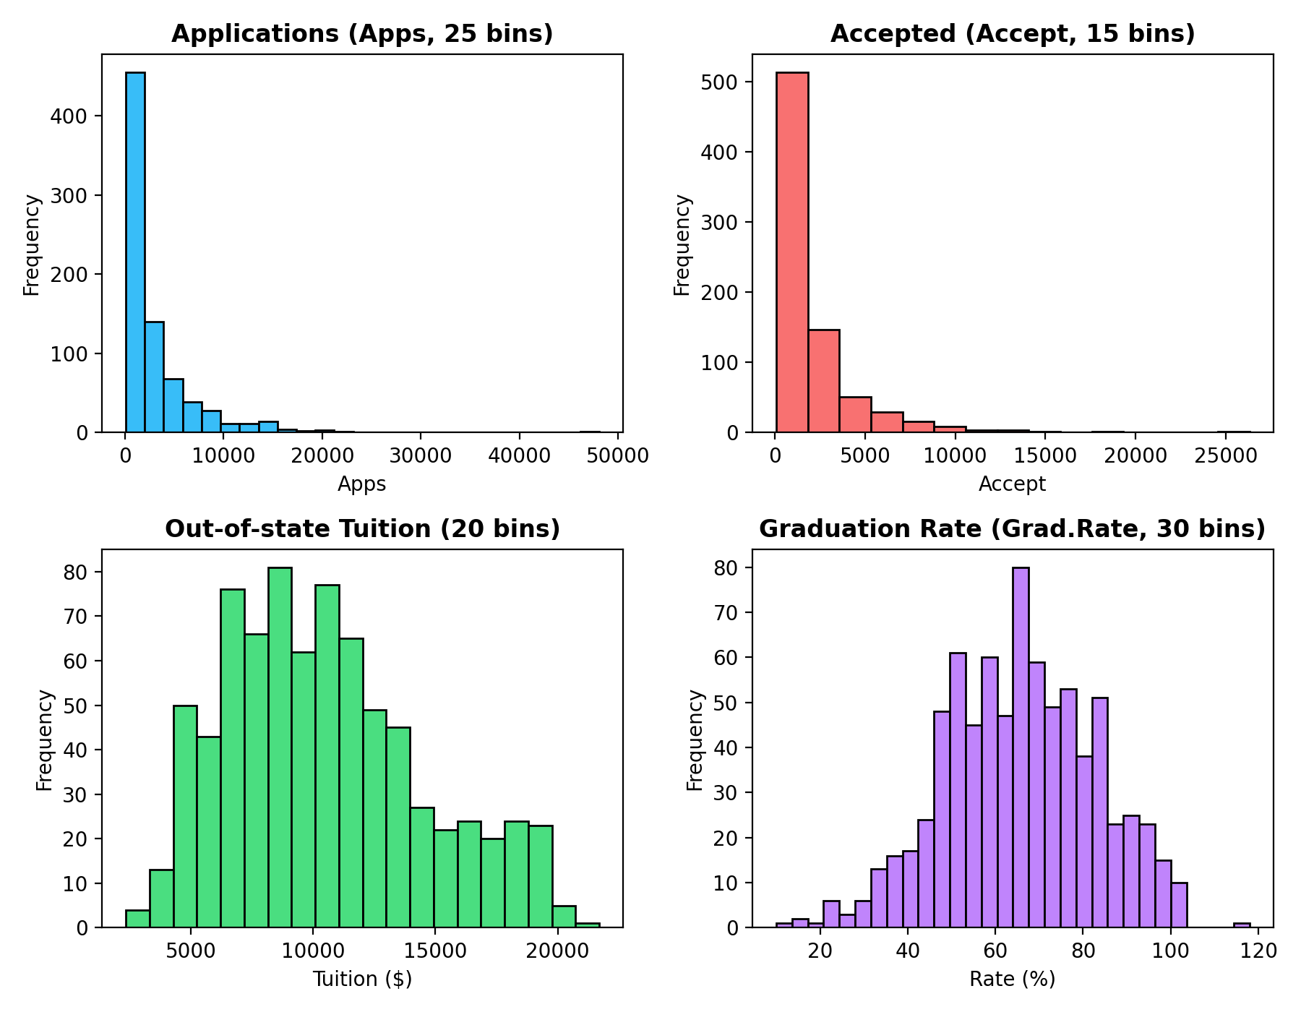
Interpretation: Private and elite universities charge substantially higher out-of-state tuition than public and non-elite schools. Application (Apps) and acceptance (Accept) volumes show severe right-skewness, whereas tuition and graduation rates display approximately symmetric distributions.
Exercise 7 – Loops and String Formatting
Formatted loop iterating over quantitative columns:
mpg mean = 23.45 sd = 7.81 above-mean share = 47.4%
cylinders mean = 5.47 sd = 1.71 above-mean share = 47.4%
displacement mean = 194.41 sd = 104.64 above-mean share = 43.4%
horsepower mean = 104.47 sd = 38.49 above-mean share = 37.8%
weight mean = 2977.58 sd = 849.40 above-mean share = 43.4%
acceleration mean = 15.54 sd = 2.76 above-mean share = 45.7%
year mean = 75.98 sd = 3.68 above-mean share = 54.1%
Interpretation: Due to positive skewness in horsepower and displacement, relatively few vehicles with extreme engine sizes pull the mean upwards, resulting in less than 45% of cars exceeding the mean. In contrast, year exhibits 54.1% above-mean share.
Exercise 8 – Estimating Bias & Variance by Simulation (Challenge)
Simulation at x0 = 1.0 with n_train = 60 over 200 replications:
d = 1: Bias^2 = 1.15608, Variance = 0.01215, Total MSE = 1.16823
d = 3: Bias^2 = 0.45406, Variance = 0.02900, Total MSE = 0.48306
d = 5: Bias^2 = 0.00817, Variance = 0.01492, Total MSE = 0.02310
d = 10: Bias^2 = 0.00016, Variance = 0.02500, Total MSE = 0.02517
d = 15: Bias^2 = 0.00000, Variance = 0.04477, Total MSE = 0.04477
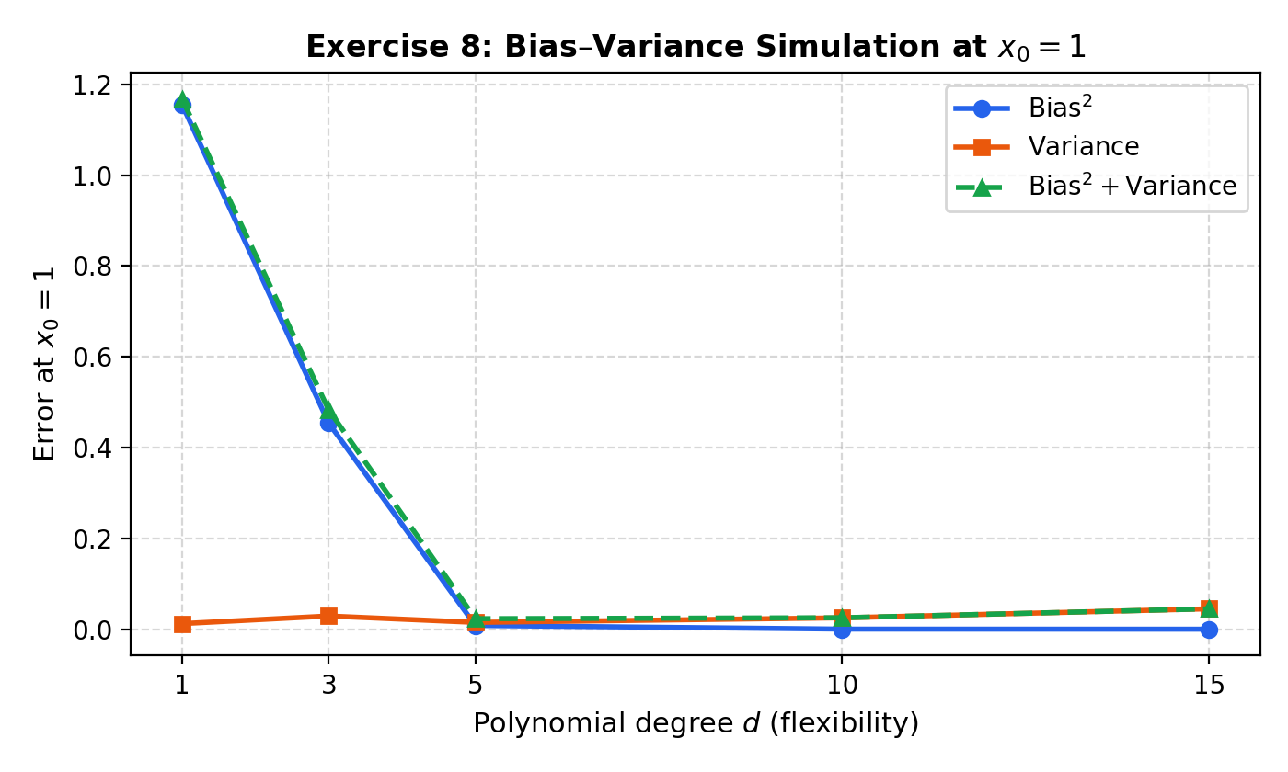
Interpretation: The empirical curves precisely corroborate statistical learning theory: as polynomial degree d increases, Bias^2 vanishes while model variance increases at high degrees due to noise overfitting. The total error curve forms a distinctive U-shape with the optimal trade-off achieved around degree d = 5.
Exercise 9 – Choosing K for KNN (Challenge)
Evaluating KNN classification test error over K = 1, 2, ..., 100:
Optimal K: 90 (Minimum test error rate = 0.1260)
At K = 1 : Training error = 0.0000, Test error = 0.2070
At K = 90 : Training error = 0.1525, Test error = 0.1260
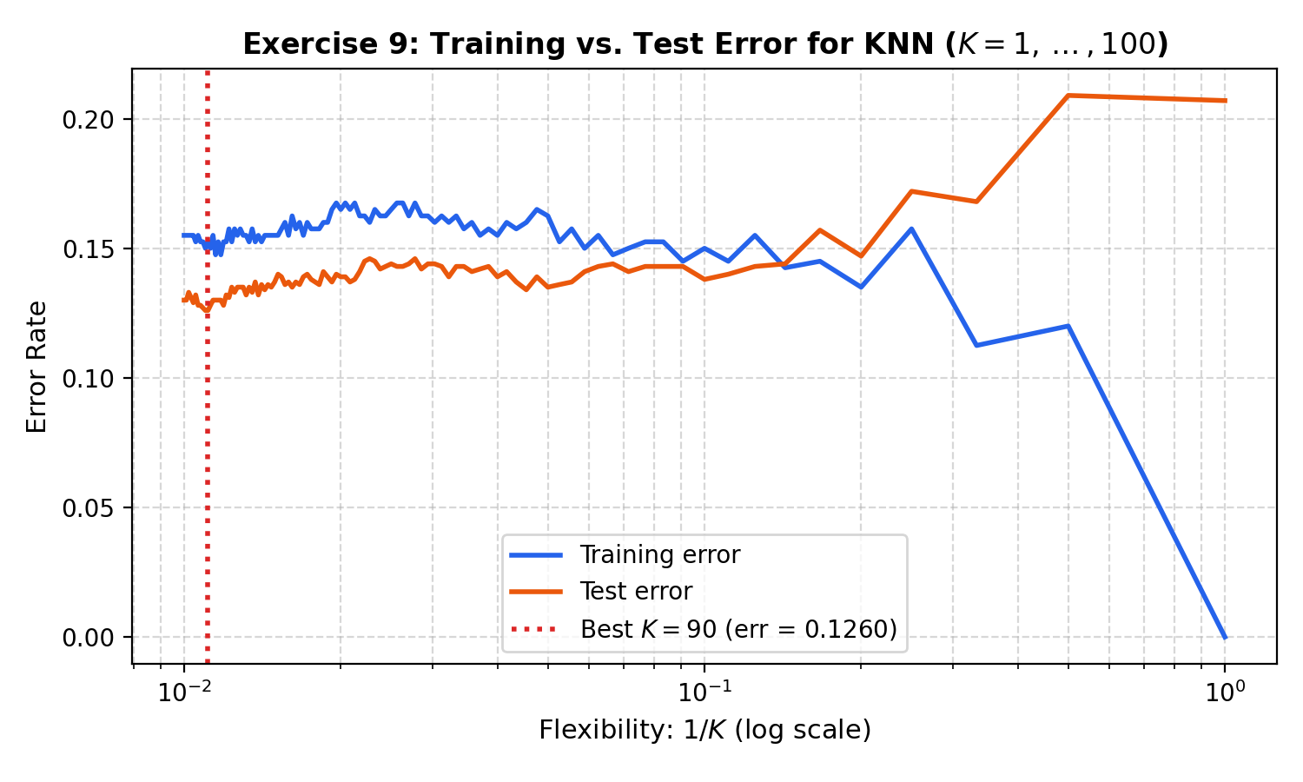
Interpretation: At K = 1 (highest flexibility, 1/K = 1), training error is 0 but test error is high (0.2070) due to overfitting sample noise. Increasing K smooths the decision boundary, reducing test error to its minimum near K = 90 (0.1260). This faithfully reproduces Figure 2.17 in ISLR.

